## Ayobami Ajala

R11720649

Assignment 1

Software Engineering

## 1. Layered Architecture:

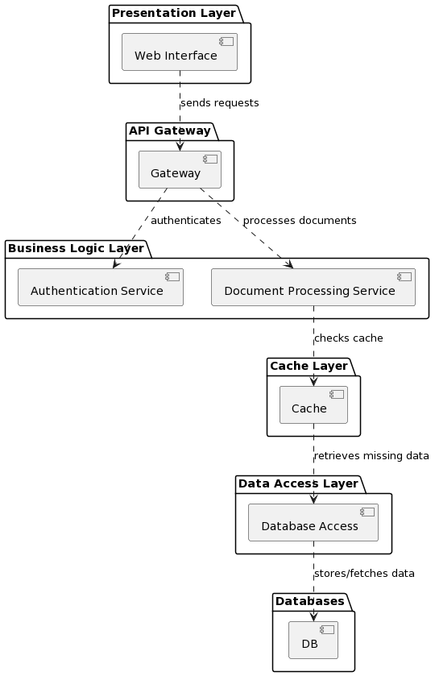

Figure 1

## 2. Repository Architecture:

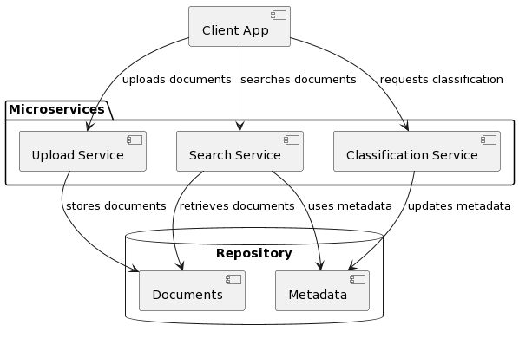

Figure 2

## 3. Client-Server Architecture:

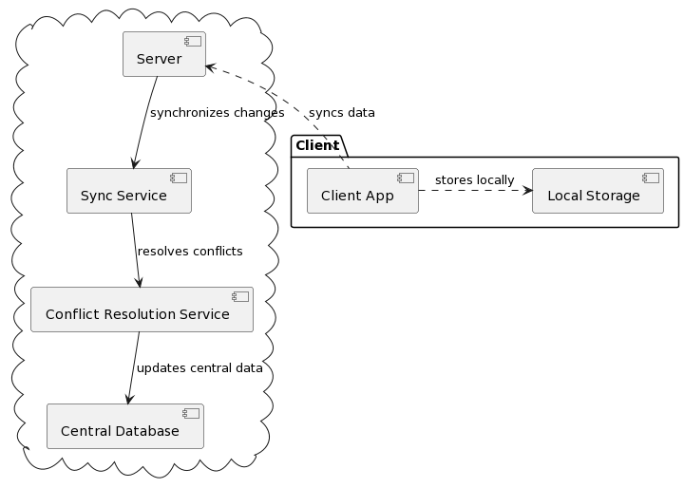

Figure 3

## 4. Event Driven Architecture:

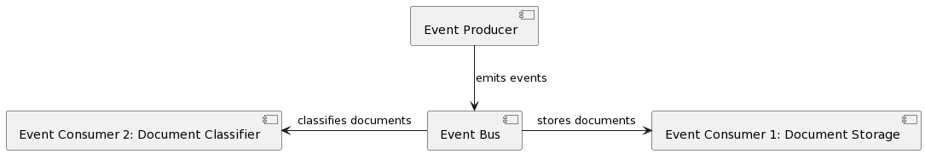

Figure 4

## 5. Comparison Table:

|  |  |  |  |  |  |  |
| --- | --- | --- | --- | --- | --- | --- |
| **Architecture** | **Pros** | **Cons** | **Scalable?** | **Maintainable?** | **Security?** | **Performance** |
| **Layered** | Allows for easy updates and model swaps; clear structure for development. | Can become complex with too many layers; may slow down direct communication. | Scalable if designed with stateless layers. | High, due to clear separation of concerns. | Layers add multiple checkpoints for security. | Can be optimized for performance with careful design of layers. |
| **Repository** | Immediate processing and classification; centralized data handling. | Central point of failure risk; complex real-time processing requirements. | Scalable with challenges in real-time data handling. | Moderate, depending on the complexity of the repository. | Central repository can be secured effectively but is a lucrative target. | High performance for data retrieval and classification. |
| **Client-Server** | Distribution of workload; clients are not burdened with processing. | Dependency on server availability and network latency. | Highly scalable with server clusters and load balancing. | Server maintenance can be complex; clients are easier to maintain. | Requires robust server-side security; client communication needs encryption. | Performance depends on server capacity and network efficiency. |
| **Event-Driven** | Highly responsive and excellent for asynchronous tasks. | Complexity in managing and monitoring events and services. | Highly scalable as components can be scaled independently. | High, if services are loosely coupled and events are well-defined. | Event handlers must be secure; potential for secure message queues. | Generally high; depends on the efficiency of event processing. |